Steps to create vpc peering:

It is used to provide communication between two vpc present in same or different region.

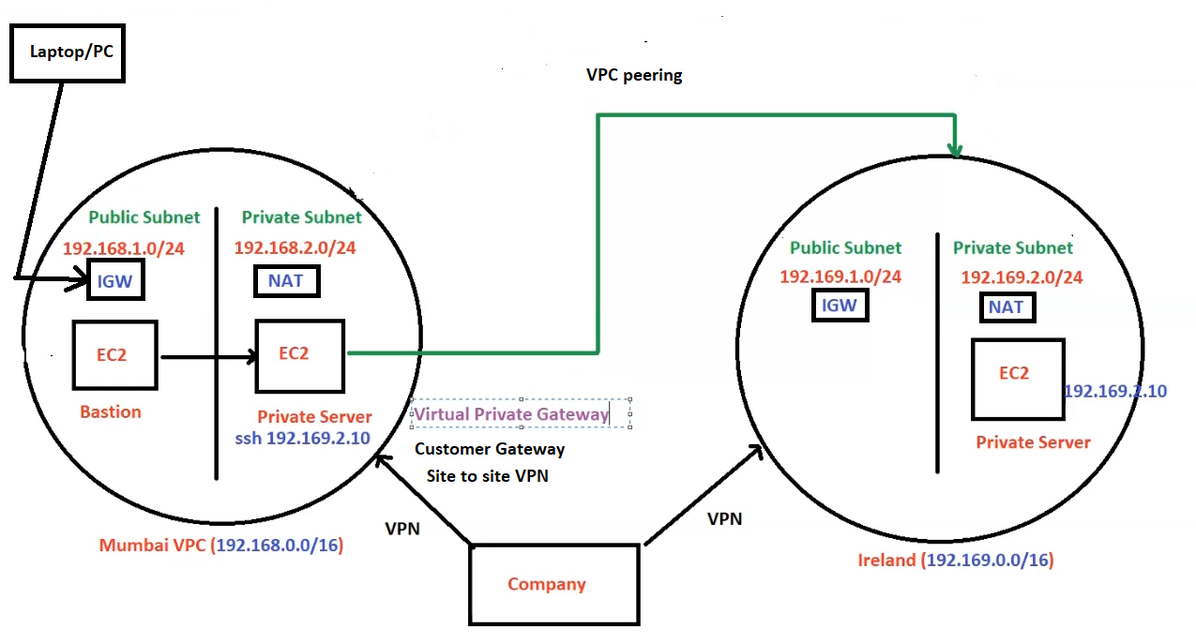

1. Create Two VPC, in one vpc create bastion server to connect private server. And in other vpc create only private server.
2. Using Bastion server we can connect to private server.
3. Then from private server we can connect to other private server using vpn peering.
4. Then Goto peering connections.
5. In **Peering connection settings, in** Name *– optional enter name of peering connections.*
6. Then in Select **a local VPC to peer with select vpc**(from where we want to connect to other

region vpc).

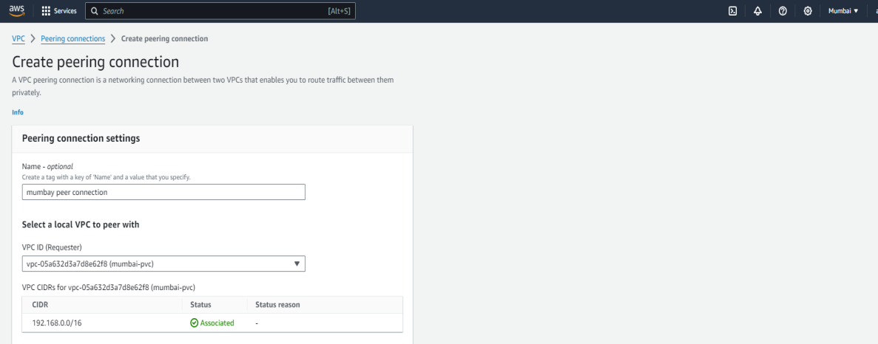

1. Then In **Select another VPC to peer with.**

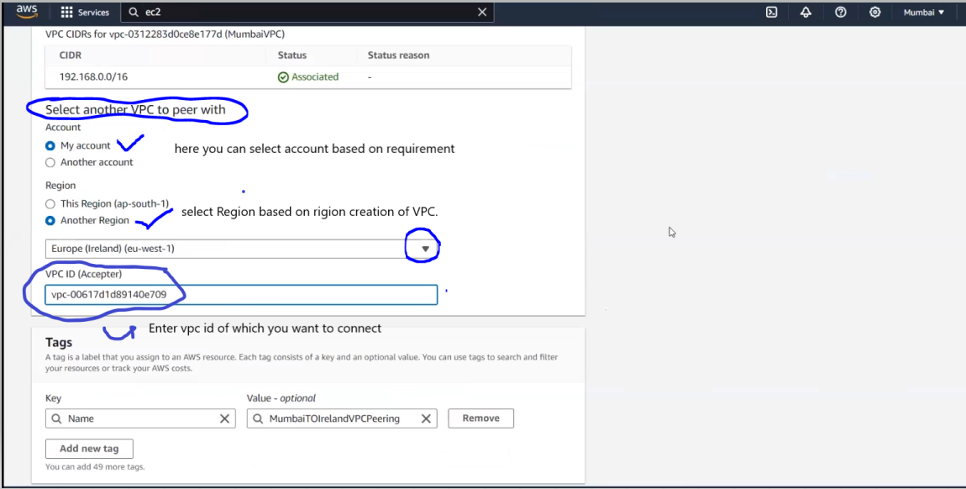

1. Then click on **Create Peering connection.**
2. After that we need to **accept** peering connection from vpc which you want to connect.

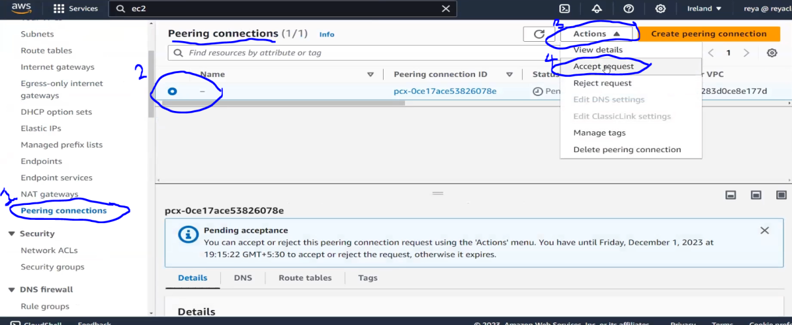

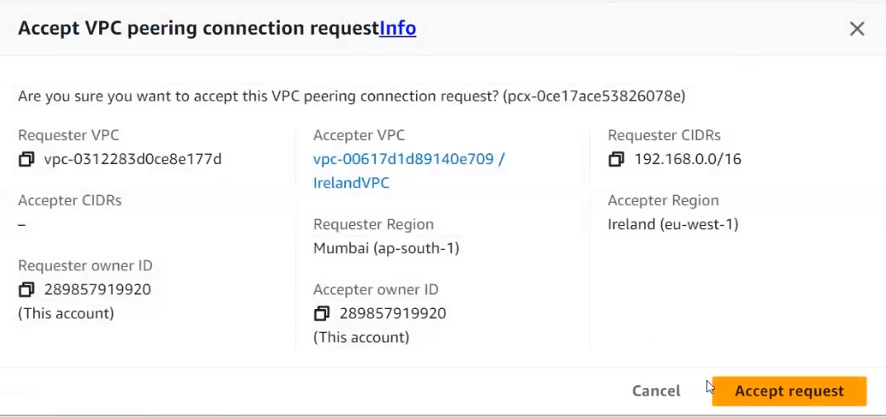

1. Then add cidr(ip) of one vpc to route of other and vice versa.

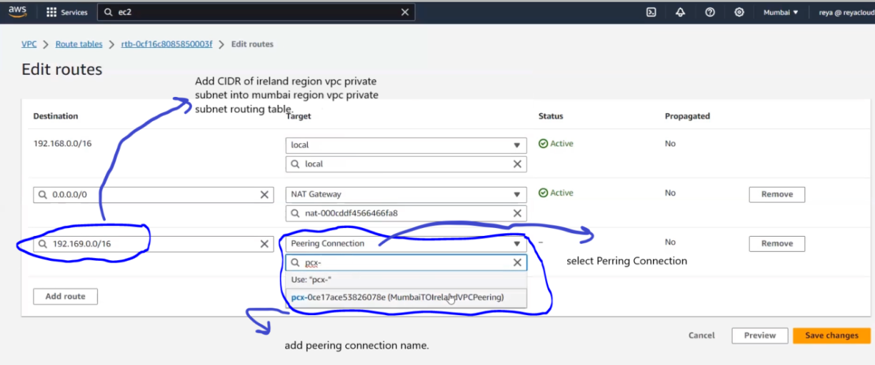

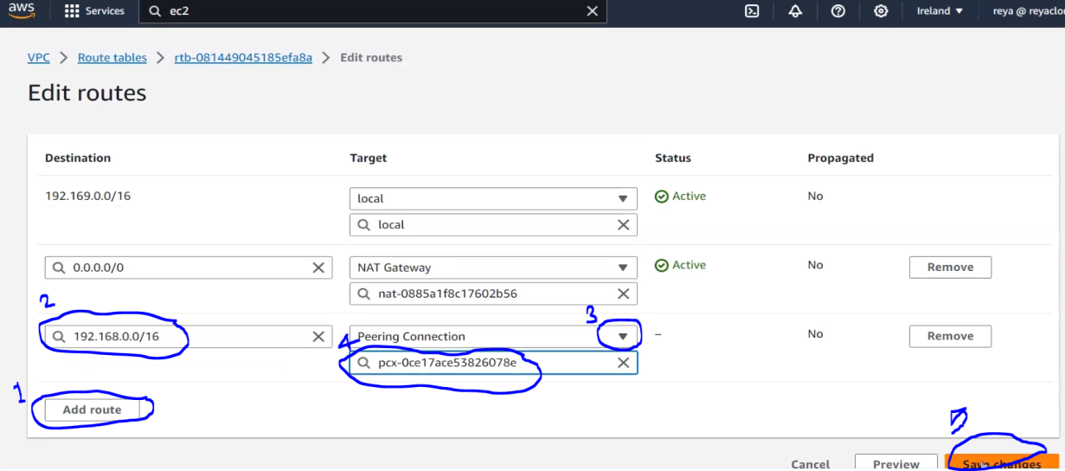

1. Then we need to add private ip of Ireland vpc ec2instance (private server) into Mumbai security group and vice versa.

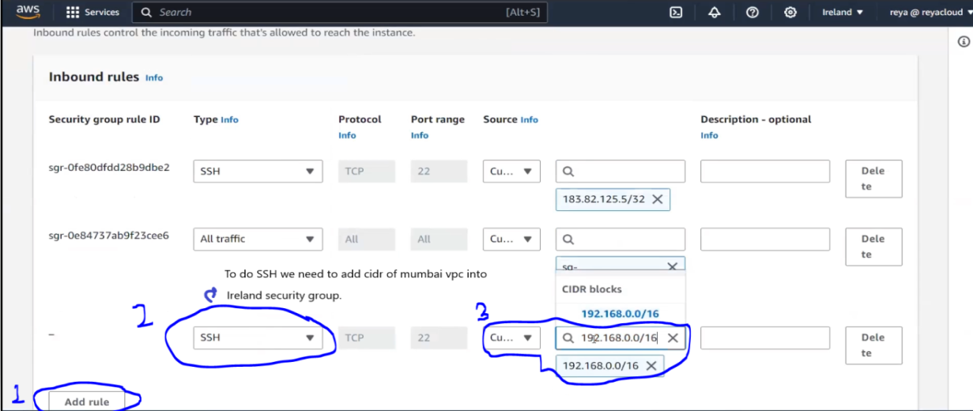

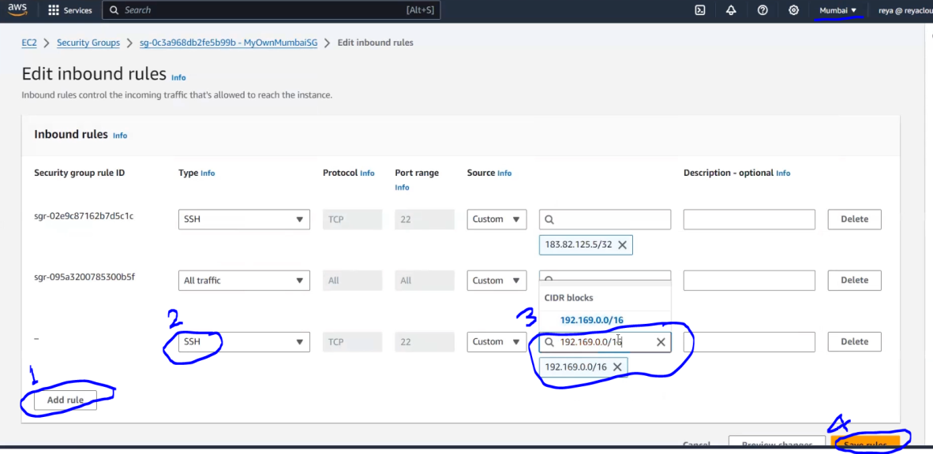

1. Then do SSH to Ireland private server ip.

